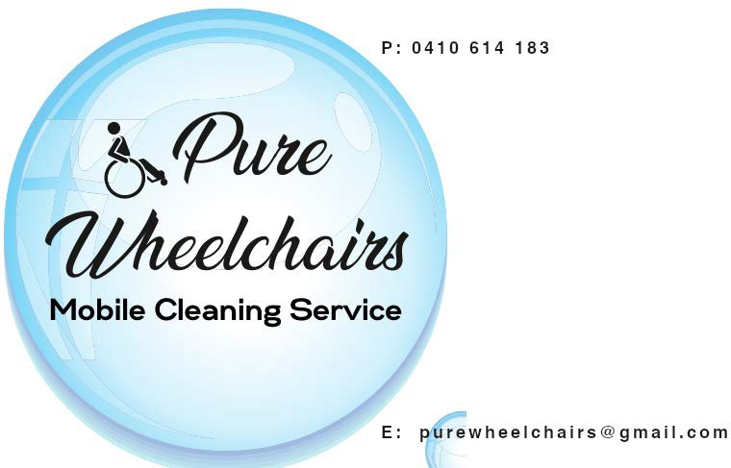
Consent Form – Participant
Version:

1.00

I, [Print Name], consent to having this conversation regarding the written complaint received, [Insert Assigned Complaint Reference Number], recorded for the purposes of the investigation of the incident. If the conversation requires audio or video recording for clarity of information or to record any visual evidence to support the complaint, I also give my consent to the recording of the conversation in audio or video form.
Date:
Time:

Signature:

Incident Notes:

This document is copyright to Robert Green (0490 251 615) and is used with permission by the provider.
Copying and/or sharing with other than this user is a breach of copyright and may be actionable.

Provider Name: Pure Wheelchairs

Page 1 of 2

Tick if: -

Video record has been made Audio record has been made

Notes written by:

Date:

Time:

Signature:

This document is copyright to Robert Green (0490 251 615) and is used with permission by the provider.
Copying and/or sharing with other than this user is a breach of copyright and may be actionable.

Provider Name: Pure Wheelchairs

Page 2 of 2

